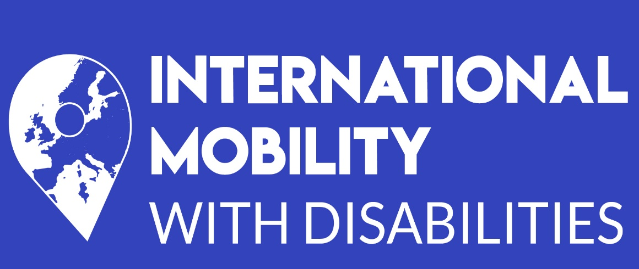
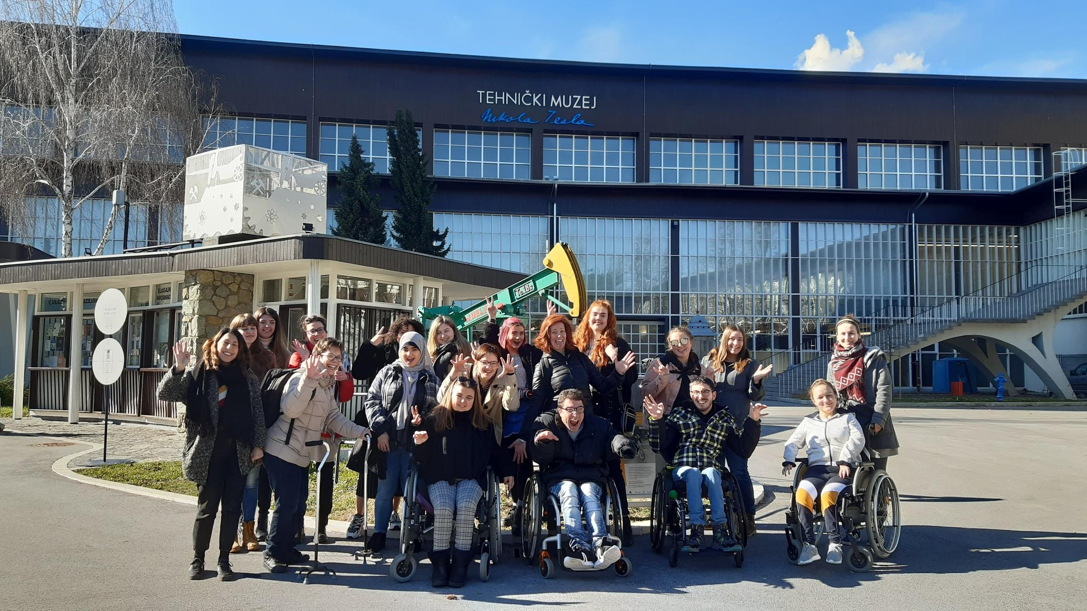
International Mobility with Disabilities

Training 25th - 29th February 2020

REPORT
This document is adapted for screen readers (reading time: 1 hour and 10 minutes)

Summary

Context 2

Objectives of the training 5

International mobility testimonials by young people with disabilities from Zamisli 6

Workshop n°1 : what information should be presented in the online platform 7
Workshop n°2 : design a toolbox for youth workers 12
Workshop n°3.1 : Good criteria for hosting structures to welcome young people with disabilities 15
Workshop n°3.2 : Create an inclusive event 18
Workshop n°4.1 : Testimonials 20
Workshop n°4.2 : Project communication plan 22
Workshop n°5 : recommendations on personal assistants 23
Workshop n°6 : Youthpass 25

Cultural activities 26

Annexes 32

Context

The training

This training took part in the International Mobility with Disabilities project from 25th to 29th February 2020. It happened in the middle of the project duration and gathered 15 participants in a mixed mobility between young people with disabilities and youth workers from the youth sector and disability sector. 7 people carried disabilities: deaf, blind, dys and several forms of reduced mobility (wheelchair-users and non-wheelchair-users). 8 people were youth workers from partner organizations: Ahead, Droit au Savoir, Erasmus Student Network France, SV-Bildungswerk, Zamisli.

The training’s main purpose was to gather people from various backgrounds and life experiences to discuss about how to make international mobility more inclusive for young people with disabilities.

The training took place in Zagreb, Hotel Laguna. We would like to warmly thank all Zamisli’s team involved in the logistic preparation of the event and who also organized cultural activities.

The International Mobility with Disabilities project

This 2-year project is funded by the Erasmus + Youth and Sports Agency from February 2019 to January 2021.
It aims at providing accessible information for youth with disabilities about all stages of the mobility path (pre-departure, on-site, return). The project also allows youth structures and youth workers to better understand the challenges faced by youth with disabilities while travelling abroad. It also brings together actors of disability and those of international mobility by involving young people with disabilities, their families and careers, youth workers and youth associations.
The main result is an online and accessible platform to inform young people and youth workers about all steps of international mobility, programmes available, and how to deal with it as a disabled person. Part of the platform is dedicated to youth workers to better understand disability issues and how they affect young people wishing to go abroad. The idea is to support young people while preparing their international mobility but also to welcome them upon their arrival in a new country.

Project partners are the following:
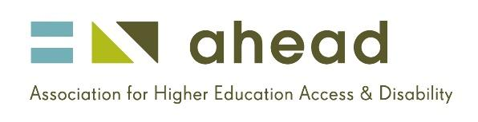
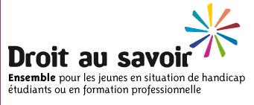
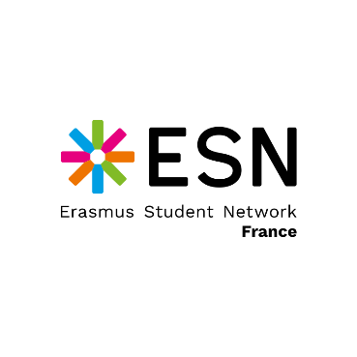
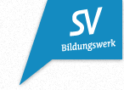
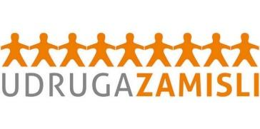
Ahead (Ireland) is the national centre for Inclusive Education. It works with higher education sector to improve the transition for students with disabilities into education and employment.

Droit au Savoir (France) is an inter-associative and cross-disability collective that promotes the pursuit of studies of young people with disabilities over 16 years old until their professional integration.

Erasmus Student Network France is a student association network to welcome international students and raise awareness about international mobility.

Jugendinfos (Austria) is the national network of Austrian Youth Information Centres coordinating national youth information projects and training youth workers. It is also the national agency for EURODESK.

SV-Bildungswerk (Germany) was founded by former student representatives. The objective is fostering skills upgrading and knowledge sharing between high school unions, thus focusing on peer-learning and democratic education.

Udruga Zamisli (Croatia) is an association promoting quality education for young people with disabilities. It is a support and information centre for young people with disabilities.

Several other partners are part of the advisory committee to provide expertise in the fields of disability, youth information and international mobility.

The consortium is developing several tools and activities to reach its objectives:
- Lead a study on short international mobilities in Europe, by looking for the most adaptive exchange programmes available for youth with disabilities. Length of international mobility is essential. Study results will be used as recommendations on how to better include youth with disabilities in international exchange programmes.

- Lead a study on best welcome practices in Europe, by investigating on how to support youth with disabilities when they arrive in a new country. The results will help the consortium to build up recommendations for youth workers on how to welcome and support youth with disabilities.

- Develop a toolbox for youth workers to help them better understand challenges faced by youth with disabilities going abroad, how to support them while preparing their journey and during their stay abroad, etc. This toolbox will include a MOOC with videos and testimonials.

- These studies and tools are going to be integrated into an online and accessible platform. One main feature will be a European map with the main organizations providing information for youth with disabilities and about international mobility (at the European and national level). These organizations can help young people with different type of information, such as administrative, housing, accessibility, health system, etc.

Objectives of the training

The training’s main purpose was to gather people from various backgrounds and life experiences to discuss about how to make international mobility more inclusive for young people with disabilities.
As it took place in the middle of the project duration, it was also an opportunity to assess productions made so far, even incomplete. By presenting productions to young people with disabilities, we have received valuable feedbacks to improve what has been done so far and what is left to do. This allows us to get closer to people’s needs, both with disabilities and from youth workers as well.
Participants came from different countries: Croatia, France, Ireland, Germany. By travelling to Zagreb, capital city of Croatia, they experienced an international mobility. Young participants with disabilities could share their past experiences in other countries whether it was for youth exchange, Erasmus for students, language assistant, or any other international mobility program.
First workshop of the training focused on defining expectations from each participant, as the whole training was based on a participative approach. Thus, participants set up their desires to:
- dig into issues of inclusion and disabilities from different point of view
- learn about needs and ways to become more independent
- share insights on accessibility and talk about barriers experienced in different countries, including anxiety to travel abroad
- define inclusive activities to do during international mobilities
- share positive and negative experiences and lessons learnt from it
- learn how to create video content
- improve English skills
- discover Zagreb and Croatian culture

International mobility testimonials by young people with disabilities from Zamisli

To introduce the training, two participants (Ivana and Nevena) from Zamisli presented their international mobility experiences.
They concluded with some learning outcomes to improve international mobility of young people with disabilities:

- raise awareness of a person with disability to express his/her real needs with as much as precision as possible
- empower a person with disability to identify challenges on his/her own and to actively participate in finding the solutions needed
- create and encourage open communication with all participants of mobility programmes
- have flexibility in activities
- prepare in advance as much as possible

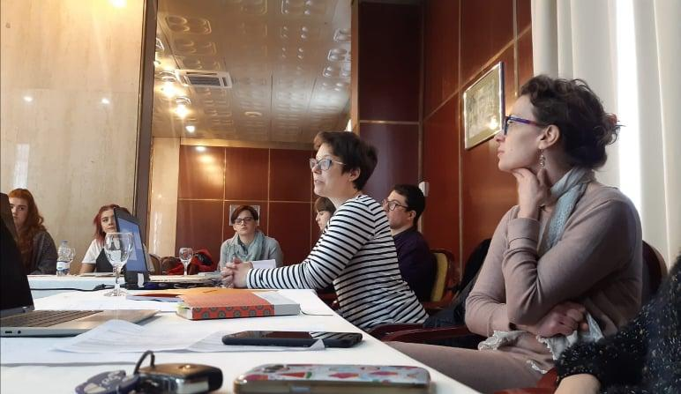

Workshop n°1: what information should be presented in the online platform?

Platform presentation
The online platform, to be launched by the second half of March 2020, has two targets:
- inform young people with disabilities of mobility opportunities and how to get ready at every stage of an international mobility (preparation, in-site, coming back)
- raise awareness and give practical tools for anyone in charge of supporting young people with disabilities (meaning youth workers, university staff members, sending and hosting structure staff etc.)
It provides several sections:
- an info centre for young people with disabilities and youth workers
- a contact map of Europe
- a forum to share advice
- a news sections

Workshop methodology

Objectives of this workshop were the following:

- learn more about European and national mobility programs
- Define key elements to be provided based on personal experience for young people with disabilities and for youth workers
The workshop was splitted in three times:
- collective brainstorming about international mobility programs each participant knows
- splitted into 4 groups, think about what types of information should be provided in the online platform for young people with disabilities and for youth workers
- each group presents its results

For more details, the workshop outline can be found in the annexes section of this report.

Increase knowledge of international mobility programs

As introduction, a short brainstorming has been done about what mobility programs participants knew. As most of participants have already been abroad through at least one of these programs, there is a rather good knowledge of it. Thus, it was possible to distinguish European and national programs.
For European programs:

- Erasmus + for students, interns, university staff members, youth exchanges
- European Solidarity Corps
- Mobility offered through European project (such as this training or youth exchanges)

For national programs:

- Service civique à l’international (France)
- KulturWeit and WeltWerts, programs through the German Red Cross (Germany)
- National language assistant programs. These programs may differ from each country and participants didn’t know more about it.
- Washington-Ireland program (Ireland)

Note that participants were less aware of national programs, some of them didn’t even know any. It is highly possible that many more programs exist, but information doesn’t reach young people with disabilities (if not young people in general).

This confirm the need to inform about mobility programs, at least at the European level, provided in a centralized platform and where users can be redirected to other websites such as Eurodesk to learn more about available opportunities. A new lead is to provide centralized information about national programs.

What young people with disabilities need to know?
Beside of information about existing international mobility programs, young people with disabilities expressed the need to have specific and detailed information about how to do it while having a disability. Having a disability may represent an added obstacle to international mobility and barriers are numerous at all stages of mobility. It is very often that a young person drops the preparation stage as obstacles are too big and information not clear enough.

Accessible transportation
In the preparation stage, it must be provided detailed information about how to travel with a disability. Not only at the international level (from one country to another) but also inside a country and even a city as there is very little common system of accessible transportation between these levels. All types of transportation must be found car, bus, taxis, trains, planes and boats.
Also, information related to each type (or category of disability) and accessible transportation must be provided. A blind person and a wheelchair user may not have the same needs about transportation for example. So, it could be useful to distinguish this.

Testimonials
Peer-to-peer is central to our project and to people’s needs. First, it allows to share real life experience, to prove that international mobility is possible for young people with disabilities and many people have done it. It is also a good way to create a sense of belonging to a community of dynamic young people driven by solidarity.
Thus, testimonials must be provided in accessible videos but also in written version as not everyone is at ease with making videos. One participant even suggested a virtual reality experience (a day in my life as an international student with disabilities for example) though this wouldn’t be possible within this project. This is an interesting idea to keep in mind. Testimonials should talk about positive and negative aspects of one’s experience abroad. It is important to talk about what happened well to promote international mobility but also about the less positive elements in order to prepare other young people to face these negative points and suggest them solutions based on experience.
An original approach to the testimonial section was to include local young disabled people who can also share their tips and advice to travel in their country and their city. It also encourages the creation of a global community made of international and local young people with disabilities.
Furthermore, this testimonial section should link to a forum, a Facebook group or a WhatsApp channel to allow better exchanges and contacts between young people with disabilities.

What to expect and ask from sending and hosting organizations?
As some programs involve sending and hosting organizations (youth exchanges, Erasmus for students etc.), it is very important to create more effective coordination between organizations and the young person with disability. It is essential to give the young one an active and central part in the process as he/she better knows his/her needs. Sending and hosting organizations must not assume needs and expectations. So, it is important to encourage young people with disabilities to talk with organizations.
In order to better express needs, a checklist to be filled-in by young people with disabilities should be provided in the platform. This checklist aims at giving young people a simple and clear tool to help organizations better understand what they must provide.
On the other hand, sending and hosting organizations must be clear on what kind of help they can offer to young people with disabilities. Can they directly deal with accommodation, everyday activities, support systems for studying etc.? It is very important for everyone to know in advance what the young person should organize by him/herself and what is directly provided by the organizations.
Some guidelines on how and what to ask to organizations should be given to young people with disabilities in the platform. It is also important to encourage young people with disabilities and organizations to exchange their contact information.

Social elements
Some tips and advices on social elements are interesting to provide as international mobility is not all about administrative and logistic issues. Socializing is essential in such international experiences. Thus, some advice on how to find information on accessible activities available should be given through the platform, as well as how to get in touch with local associations for young people with disabilities in order to find support, advice on local life but also meet new people. As we encourage an inclusive and independent international mobility, the same should be done with non-disabled organizations and youth associations so that young people with disabilities can participate in everyday activities and find social opportunities the way they want.

Tools to promote learnings from international mobility experience
It is always said that international mobility has a huge impact on people’s employability. Indeed, international mobility doesn’t stop when participants are coming back to their home. There is a lot happening after the mobility itself and it is a great opportunity to add this experience in CVs and cover letters. The platform should support this stage of mobility by showing examples of CVs, cover letters, application forms for young people with disabilities to help them talk about their learnings. It should also promote existing European tools.

Other elements to give to young people with disabilities:

- how to deal with cultural attitudes to disabilities in different countries
- information on grants
- list of doctors and ambulances
- how to get health insurance (to go to non-EU countries)
- how to find accessible accommodation
- information about getting a personal assistant (who pays for them, where to find them etc.)

Moreover, this workshop questioned the possibility to provide this information and more about different system by breaking it down into sections for different categories of disabilities.
E.g.: Specific guidance for blind people, specific information for wheelchair users.

What information to provide to youth workers and other people supporting youth with disabilities?

In addition to young people with disabilities, sending and hosting structures are fully taking part in the process of international mobility. The platform aims at giving them information on how to support young people with disabilities. These structures are diverse and led by different kind of professionals: youth workers, university staff members, NGOs staff members, volunteers, disability officers, animators, experts and non-experts. Not all of them are aware of issues faced by young people with disabilities and how to deal with it.

Most important, some elements breaking stereotypes about international mobility and disabilities are important to be showcased in the platform to show that it is possible to send or host a young person with a disability abroad. For example, a guide on terminology about disabilities could be interesting, as well as key questions to better assess accessibility of your own country and/or city. But also, testimonials of organizations who already did international mobility with young people with disabilities to give some tips on how it’s done. it could also be useful to encourage sending and hosting organizations to be in contact with experts on disabilities and disabilities associations. These people can be good help in case of emergency.
Most of information provided to young people with disabilities are also useful for youth workers and other professionals. Such as transportation, accommodation, personal assistant, grants etc. Most important some specific advice on how to give proper information to young people with disabilities with all these elements is essential.

Other elements
Our brainstorming session brought us other elements that don’t quite fit the platform’s spirit though we think these elements are interested to keep in mind and can be advocated in our respective networks.

- Encourage cities and tourism offices to provide accessible tour guide brochures
- Create a map of accessible public bathrooms and other public places
- Advocate for a European policy agreement to better support young people with disability going abroad

Workshop n°2: design a toolbox for youth workers
Toolbox presentation

The toolbox is targeting youth workers, university international officers, volunteer from NGOs and youth associations, NGOs staff members … in other words everyone involved in international mobility programmes.
This toolbox aims at giving them tools to better support young people with disabilities during all stages of international mobility (information, preparation, on-site, return).
The main content of the toolbox is going to be similar to an online course (or MOOC) with video and textual contents, quizzes to assess knowledge and uploadable documents to go further.

Workshop methodology

Based on workshop n°1 brainstorming on what should be provided in the platform, SVB and Ahead sorted out recommendations of what should be provided in the platform into two categories: FAQ and toolbox. Recommendations have been shared into 4 groups in charge of defining if content should be in video or textual content. Then participants were invited to define if these information should be presented for the preparation stage of mobility, during mobility or after mobility.
Additional time was given to brainstorm on any other ideas that came to mind during the workshop.

Results

Thoughts and inputs from this workshop are presenting by groups who worked on different topics.

Group 1
Group 1 worked on the FAQ, who is not part of the toolbox per se but we considered it was important to start working on this element for the platform. These elements are going to be used for the continuation of the project after 2021.
About accessible accommodation, it could be interesting to provide a list of web pages per country where you can filter information related to your needs and disability. A study on different housing policies for disabled people could be also an added value to better understand differences within Europe. Some video content to show what an accessible accommodation should look like could be also an interesting lead.
About public transport, it would be good to provide a document summarizing official information per countries (but accuracy of these information needs to be checked, as workshop participants experienced misleading in some places where places in reality weren’t accessible).

Other ideas:

- create a Facebook group for young people with disabilities to share their experiences
- Create a matching system for young people with disabilities: a travelling disabled young person is put in touch with a local buddy to get information about accessibility, leisure activities, administrative and logistic issues.

Group 2
Group 2 worked on several topics for the toolbox:
- Guide to understand cultural barriers towards disabilities is better as a video content which aim is to break down stereotypes with 2 or 3 different profiles of disabilities represented
- Checklist to express needs. The group said this one was a bit challenging because it is hard to generalize questions that fit all kind of disabilities. In any case, it’s better as a textual content to be downloadable. Several project partners have created their own checklist in order to better organize events, so these could be good basis to work on.
- About delivering travel information, it could be interesting to have a video showing people what it looks like to go through an airport (for example) as a person with disability. But textual content that gives reminders of important points and general information on how to prepare a travel is more important. A point about how to ask someone information on his/her disability is also central to the toolbox.
Other ideas:
- some advice on how international mobility help young people with disabilities to develop soft skills
- create a checklist of accessible places in a city or in a country
- provide information about accessible work opportunities in host country for students with example

Group 3
Group 3 made very interesting comments on web accessibility. They suggested to avoid pictures as much as possible as it is inaccessible for visual impaired people. But when a picture is used, or even textual content, it is essential to check accessibility. Same for video content.
- CV templates should not take a large section of the website, but it could be better to have some shorter templates (showing where to include your international mobility experience in your CV, not talking about the whole CV).
- To help youth workers to support young people with disabilities in defining skills learnt during a mobility, a video content could be effective.
- Create a quiz within the toolbox to be sure that users have read and absorbed all information. Provide these quizzes at the end of each section to test knowledge and if you got wrong answers you are blocked to the former section.
Group 3 also gave other ideas. They proposed videos showing places and users must point-and-click what accessibility supports are missing as a game quiz.
The toolbox should present information on all different disabilities, including invisible disabilities.

Group 4
Group 4 focused on three different topics to help youth workers provide social elements to young people with disabilities, information on support systems per disabilities and guidelines on cultural differences.
Social elements/Making friends:
- A video content should provide advice to youth workers on how to create safe space for acceptance and inclusive groups. But also, video content should provide examples of everyday inclusive and accessible activities that can be done.
- Textual content is providing more details about how to organize accessible group activities (indoor and outdoor), create inclusive energiser, and how to create an inclusive city tour
Information on support systems per disabilities
- Video content should give youth workers information on where to look for and how to inform about different types of support e.g.: using public transport, what to ask, how to assist etc.
- Textual content is gathered in guidelines on how to ensure activities are accessible for mobility disabilities, sensory disabilities and invisible disabilities
Guidelines on cultural differences
- Video content should provide testimonials of youth workers and young people with disabilities talking about their experience, how they felt, and telling how cultural elements have to be taken into account when it comes to travel with a disability.
- Textual content could give a set of questions for youth workers to ask about their own perceptions and that of their countries.
Group 4 also provides other ideas about including information about personal assistants (explain why some young people with disabilities need them, how many are need, how they are to be included or not in activities, how to allow them to rest etc.). It could be also interesting to give youth workers a list they can fill in themselves with contact information, other organization contacts, hospitals etc. A little bit like the one given to young people with disabilities.

All these results and suggestions are going to be thoroughly studied by Ahead and SVB to create the best toolbox as possible even if everything couldn’t not be integrated to the toolbox. The objective is to select the most important elements and give hints on the others at the very least.

Workshop n°3.1: Good criteria for hosting structures to welcome young people with disabilities

When it comes to international mobility with disabilities, it is important to put young people’s perspective first. But it is also important to give tools and examples of best practices to hosting structures, whether they are or not specialized in disabilities, in order to create inclusive mobility programs.
The aim of this workshop was to define altogether main criteria of good and inclusive hosting organization.

Workshop methodology

Participants were splitted in several groups: first of 2 people, then 4 and then 8, as a waterfall. Each time they aggregated, they answered one new question. Questions were the following:

- what were problems you faced when you did an international mobility?
- what was positive when you went abroad? What happened well and could be used as an example?
- What do you need for your host structure?

These questions allow us to better frame the current situation based on testimonials from participants with disabilities and to have more information about obstacles and disincentives. Based on answers, we are able to define good criteria for hosting structures. This work is going to be improved through our research about good welcoming practices for hosting structures.

Problems experimented by participants

Some problems are related to external causes from hosting structures. These are mostly due to accessibility of buildings, transports and other environment hosting structures cannot act on. It can be cobblestones, narrow pedestrian ways, lack of accessible transports and public bathrooms.

But hosting structures also share their part by providing inclusive international solutions. Problems faced by participants were numerous. They received no information about accommodation, transport solutions (local and international). Someone was discouraged to go on Erasmus because sending and hosting organizations wouldn’t offer support. For another participant who is deaf, it was hard to understand people speaking because of their accent and they were not very understanding about deafness (they laughed sometimes). Other faced situation with their luggage that are sometimes heavier than other young people because they have to carry more things (medicine, support material…).
Young people with disabilities need more information to plan way in advance their activities as it can take more time to get prepared for the day, or it takes more time to move for example. So, when sending and hosting structures do not provide a planning of activities it can be very complex to handle everything.

One major issue was about personal assistants.
Nothing was thought about assistants. For example, accommodations didn’t have two rooms (one for the disabled person, another one for his/her assistant).
Grants didn’t foresee more than one assistant per young person with disability, but it often needs more because of the disability and the length of the mobility. Some assistant are volunteers and don’t get compensated for their work.

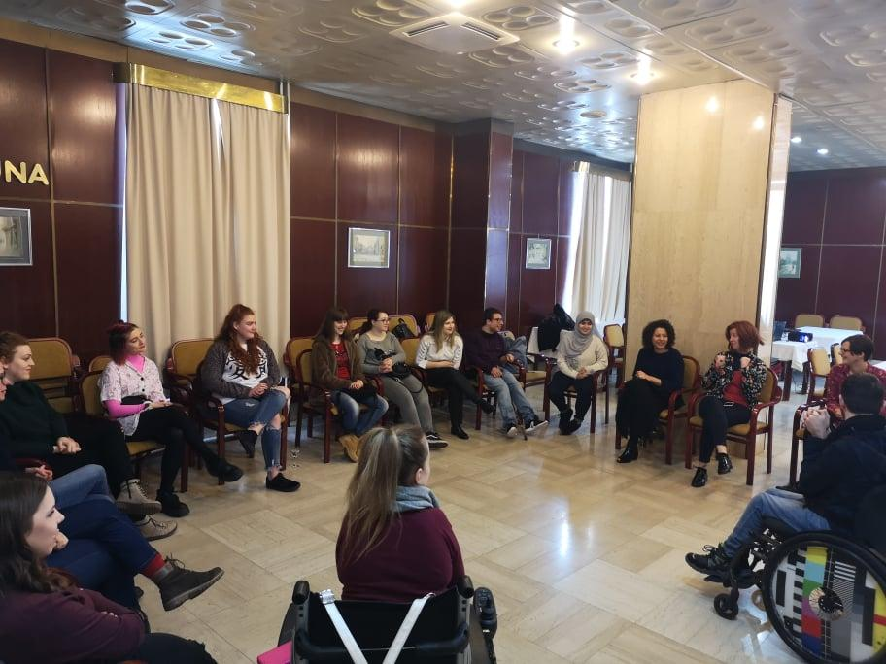
In some places, people are unwilling to make changes. Some programs don’t provide assistant and interpreters.

Participants sitting in circle

Positive aspects of experiences abroad

Rooms were quiet. Doors could be opened by pushing a button, this was very modern. Attitudes toward disability was very progressive. Some airport securities are nice and understanding. Most of them are speaking English.
There are a lot of improvements about accessibility in many European countries that give hopes. Most institutions are now getting elevators. In general, institutions and people are getting more aware about disabilities. And people are getting more open-minded.
It was great to discover another country.
It was relieving to travel with someone. It was also a relief when everything is provided in advance.

Criteria for hosting structures

Get in touch with young person prior arrival to reassure him/her and give information about accessibility.
Accessible rooms and accommodations.
Be sure that the place where activities are held have a lot of facilities nearby.
Give information about sports and activities available.
Plan in advance activities by involving young people with disabilities.
Make sure to provide all important information to young people with disabilities participating to your activities.
Prepare in advance the needs of young people with disabilities and involve them in the preparation.
Prepare suitable and accessible list of activities, transportation, accommodation.
Any text and presentations must be provided in digital format.
It is important to listen to young people with disabilities.

Workshop n°3.2: Create an inclusive event

Some hosting structures all over Europe are youth associations led by young people eager to welcome young international people in their home city. Other hosting structures are part of youth exchanges and are willing to be as inclusive as possible. Very few of them are specialized in disability. Thus, they often don’t know how to welcome young people with disability and tailor activities for them, so they don’t feel excluded from other participants. Many of these associations (youth associations and/or being part of youth exchanges) are event organizers, whether these events can last one evening to several weeks.
Thus, it seemed important to do a workshop on how to create inclusive events so these associations have guidance on their main activity, so it is more inclusive for people with disabilities. Based on findings from this workshop, partners are then going to work on a document to be uploaded in the online platform giving guidance and tips to organise an accessible event.

Workshop methodology

Methodology was quite simple. Participants were splitted in 4 groups and asked to create an event of their choice, knowing that they have to manage 10 people with disabilities and 10 people without disabilities. Every group were asked to define steps to do in advance, during and after their event so it covers all steps of organizing an event.
Everything else about the event was left to participants’ creativity.

Event 1: welcoming event for new students

The event is an evening to celebrate arrival of new international students in town.

What must be done in advance:
If needed, arrange accommodation close to the venue. Create a registration for asking about accessibility needs, and about what type of disability if any. Depending on the needs, arrange assistants. View venue before booking it to see if it’s accessible. One week before the event, give prior information about contact persons, timing, type of activities, and how to get to the venue (use pdf and word versions, you can also think about a voice record or a video with subtitles). Few days before the event, send presentations if you’re going to use some. Don’t forget, like in any other event, to ask for permission to take pictures or record videos.

During the event:
Don’t forget time for breaks if your activities are long. If changing location during the event, arrange accessible transports. Have assistance who can rotate to give breaks to each others and interpreters using international sign language if it fits participants. Don’t forget to use inclusive icebreakers to get participants to know each other, and inclusive energizers. Provide name tags. If your event is having presentations, have live captioning.
Follow up after the event: Send evaluations forms to all to ask what needs changes and ask for improvements suggestions. Write report with outputs of the event, for funders but also for participants.

Event 2: Social mixer Silent disco

A silent disco evening is a dancing evening where people are dancing to music transmitted through wireless headphones instead of music played out loud through speakers.

What must be done in advance: Send out form for dietary requirement and accessibility issues. Provide map and audio version to show/tell about accessible entrance. When giving information, use easy language and no jargon.

During event:
Give directions where accessible entrance is by printed arrows. For those having epilepsy, avoid strong flashing lights. Provide a quiet room to rest. Room must not be too dark for mobility issues, and people using sign language. Provide one room for personal assistants to allow them to rest as well (if not the same resting room as everybody). No fog machines. Make sure there is large space, to avoid overcrowding. Provide alcoholic and non-alcoholic beverages. Ear plugs for people with hearing issues when music is too loud or at least possibility to reduce volume on headphones. Have accessible taxis ready to allow people going home when they want. Provide accessible bathrooms. Provide sitting areas and tables. 4-5 people should be in charge of monitoring event.

Follow up: Ask for feedbacks of the event. Don’t forget about auto-evaluation so more events can run smoothly.

Event 4: outdoor activity

Group 4 proposed outdoor activities such as food tasting, blind dinner, and cooking in nature.

In advance:
Define a list of disabilities, to know what we have in the group of participants. To do so, send google form with right questions to find specific needs. Find accessible place, hotel and local transportation. Assure proper assistance by arranging the event for several personal assistant per participant who needs them. Create activities accessible to everyone.
During the event: Arrange accessible restaurants.

Workshop n°4.1: Testimonials

Peer-to-peer information is a wonderful trigger of motivation. This is why we would like to have a complete testimonial page with diverse profile. Not only young people with disabilities, but also with youth workers, university staff members and other international mobility actors.
Working on testimonials during the workshop is also a good occasion for participants to learn on how to create video content.

Workshop methodology
Young participants with disabilities gathered altogether to create video testimonials of their previous mobility experiences. They were tasked to define questions and then record video the way they wanted. As they have several experiences, good or bad, they better know questions they would have liked to ask before going on international mobility. Thus, questions defined during this workshop will better fit needs of young people with disabilities visiting the platform.
Two videos have been produced during this workshop. We are planning to upload them in the platform once all accessibility measures have been taken on it.

Questions to ask for testimonials

- What is your name, age, where’re you from?
- What issues do you face as a person with a disability?
- Do you believe your home country is accessible? Is doing enough for people with disabilities?
- Before traveling, do you do research before your trip on how accessible the place is and what supports may be available to you?
- Why have you decided to travel?
- What struggles do you face when going abroad?
- What changes would you like to see so that people with disabilities can succeed when traveling abroad?
- Give an example of one good and one bad experience you had when traveling abroad?
- What advice would you give to a person with a disability who is traveling abroad (or for the first time)?

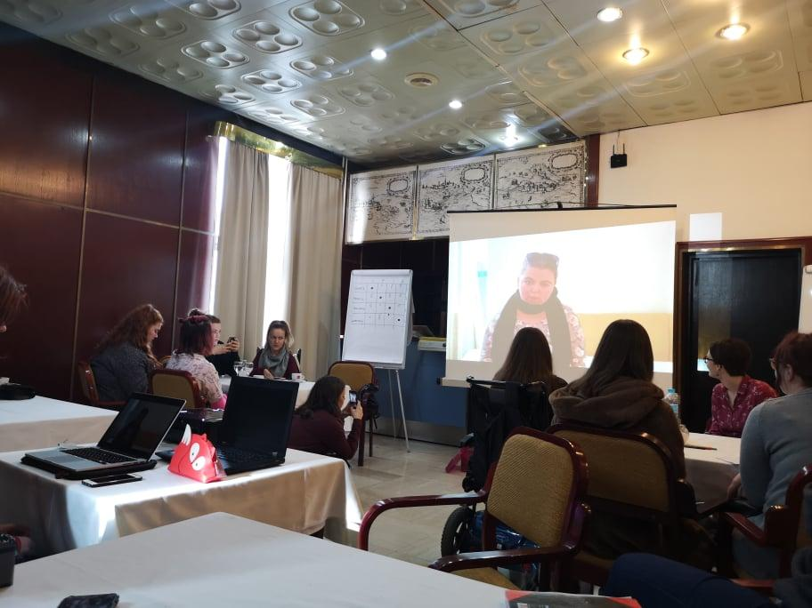
Participants looking at a video made by one of them to present her experience of international mobility

Workshop n°4.2: Project communication plan

While young participants with disabilities worked on video testimonials, youth workers worked on a communication plan for the project.
As the project is running its second and last year of operation, and some intellectual outputs are done, now has come time to dissemination of these results.

Workshop methodology

Communication plan is confidential. Consortium is going to work on it in the next months, so it remains coherent and include all levels and means of communication. It is due to start in June 2020 and goes until the end of the project, January 2021.
We also worked on precising visual universe of the project that was so far reduced to a logo, typography and colours. We would like to add some visuals that be used on the platform but also other communication materials for the project and for the communication kit used by youth workers to raise awareness about international mobility.

Scanned versions of drafted posters drawn by participants can be found in annexes of this report.

Workshop n°5: recommendations on personal assistants

On the International Day of Persons with Disabilities, December 3rd, 2019, a conference "Challenges in the Mobility of Young Persons with Disabilities" was held at the House of Europe, organized by the Association Zamisli. The theme of the conference was the importance of the support needed by people with disabilities to travel and participate in mobility programs at all levels and on an equal basis with other participants, without discrimination.
Practice examples of participation of young people with disabilities in mobility programs in Belgium, Norway, Slovenia and Germany were presented, as well as those that were done in private arrangements and with family support.
The conclusion of the Conference is that young people with disabilities should be encouraged to take various forms of mobility, but that this is possible only with quality support. The quality of support in this respect is defined depending on the type of disability, the duration of the mobility activity and the payment of the support required.
The current practice of a young person with a disability going to a youth exchange involves an accompanying assistant whose costs of travel, accommodation and food are covered, but, in most cases, the salary is not.
The accompanying person assists the person with a disability on the exchange throughout the day and is available to him/her for 24 hours, which is very intense and exceeds the limit of 8 hours (which is the normal average) of work, and depending on the type of disability of the user, requires meeting different and specific needs.
Recommendations for the Agency for Mobility and EU programs, as well as all other bodies financing mobility activities involving young people with disabilities
It is necessary to enable young people with disabilities to participate in mobility programs with appropriate support. This should take into account the type of impairment; user needs and duration of mobility activities.
Support should be provided in all required segments such as customized transportation, assistance, health needs and should be paid in accordance with real needs and real costs.
The current practice of approving one accompanying person on longer journeys is dysfunctional and unacceptable. Different needs of persons with disabilities must be taken into consideration. It is unacceptable that accompanying persons work longer than 8 hours and are paid on a lump sum per day, while often being available for 24 hours. This situation complicates the position of both the person with disability and the assistant. Regardless of what type of cost calculation is involved, it is important to follow the Labour Act. When assisting another person, the readiness and restfulness for work is very important.
As presented in the conference program, not all people with disabilities have the same needs and the same rule cannot be applied to, for example,
people with visual impairment, people with physical impairment who have difficulty moving and people with most severe disabilities. So, the minimum standard is expected to be defined:
1. Accompanied persons should have the same conditions prescribed by the Labour Act, regardless of the basis on which labour costs are paid. It is necessary to define the cost of the working hour of the accompanying person. Accompanied persons should be provided with shift work if the activity is longer than 8 hours, as with an increased hourly rate for second shifts and night work.
2. For activities lasting up to 8 hours, one assistant is sufficient for each person with disability for whom the assistant requirement is assessed, regardless of the type and degree of impairment.
3. For activities lasting longer than 8 hours, which is often the case when the length of stay is several days, it is necessary to provide as many accompanying persons as there are necessary working hours and availability for work, keeping in mind the hours of rest of the accompanying person.
4. In the case of traveling while participating in the activity, it is necessary to provide an assistant during the trip and to make sure that one person can satisfy all travel requirements so that the person with disability and luggage can reach the destination safely. Often, these are longer trips that require more luggage, and the accompanying person also has luggage, so he/she can hardly help the person with disability and carry all their luggage during the trip. It is necessary to plan the trip in detail and to realistically estimate the number of assistants needed.
5. During the stay for an activity lasting longer than 8 hours and up to three days with travel, the person with the most severe form of disability should be assisted by three accompanying persons who are scheduled according to the work plan, and when the activity is longer than three days, then four people are needed. This is necessary because of the work schedule, night work and rest that assistants need to be provided with between work activities.
6. During a stay for an activity longer than 8 hours and lasting for days (no matter how many days) with or without travel, a person with a severe disability (a person who does not have the most severe form of disability and does not depend on support for 24 hours, but can be overnight alone, while during the day she/he needs some help) or a blind person should be assisted by two people who are scheduled according to the work plan.
7. When staying for an activity lasting longer than three days with travel, the person with the most severe disability should be assisted by four accompanying persons who are scheduled according to the work plan. If a custom transport for travel is needed, the driver should also be included, not only for traveling to the venue but also to local leisure activities or during the activities in which the group goes outside the physical space, which means that the driver should be available for driving all the time.

Workshop n°6: Youthpass

Youthpass is a certificate used after youth exchanges and other Erasmus + non-formal education programmes to recognise learning outcomes for each participant. It is delivered by project managers and can be used by participants to enhance their knowledge acquired during a youth exchange. The certificate reaches a European-wide recognition.
To know more about the youthpass, please visit the website following this link : https://www.youthpass.eu/en/

Workshop methodology
In a collective brainstorming, participants were asked to define hard skills and soft skills and give some example of each according to them. We also debated the question: Today, what is the most useful between hard and soft skills?
Then, participants individually wrote down what they have learnt during the training week so they can go back to this information later for their personal use.
We’ve also presented to them a very useful tool to better identify soft skills acquired during international mobility: AKI. https://www.aki-app.org/en/
You can find in annex a list of soft skills splitted in different categories created by the AKI project team.

Cultural activities

Organizing a mixed mobility to talk about the project is a good thing but it was also the occasion to discover a new country: Croatia and its capital city Zagreb. As several nationalities were part of the training, it was also time to be aware of other people’s culture and develop intercultural skills.
While mornings were dedicated to work on the project and gather different opinions on it, participants could enjoy their afternoons by discovering more of Zagreb. Thus, 4 cultural activities have been achieved during the training:
- introduction to participants native languages (Croatian, French, Gaelic, German)
- Museum of Techniques (Tehnički Muzej)
- Photo challenge in the city centre
- Museum of broken relationships (Muzej prekinutih veza) and upper town visit

Introduction to participants native languages

We were lucky to have several nationalities represented among participants: Croatian, French, German and Irish. As everyone is eager to travel more around Europe, we decided to teach to each other basic sentences in every language. The activity was followed by a quiz to see how much we have remembered for the short and funny lesson.
As we all were very at ease with English, we decided to learn Gaelic from our Irish friends.

Words and sentences we’ve learnt were the following:

- Hello
- Goodbye
- Thank you
- Excuse me
- How are you?
- Is the building accessible?
- Can you help me? How can I help you?

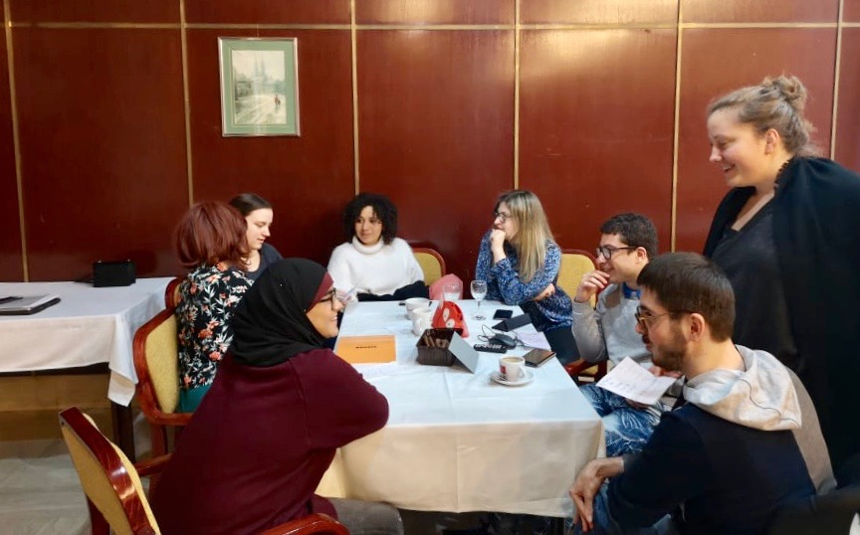
Participants laughing and trying to talk each other’s languages

Nikola Tesla Technical Museum of Zagreb

First activity outside our meeting room, it was fun to hang around collections of the Technical Museum. After a playful display of some of Nikola Tesla inventions and presentation of his life from Croatia to the United-States, we were shown models of mines for coal and iron, transportation history (car, trains, boats and planes) and the energy conversion section showing how various kind of energies are produced.
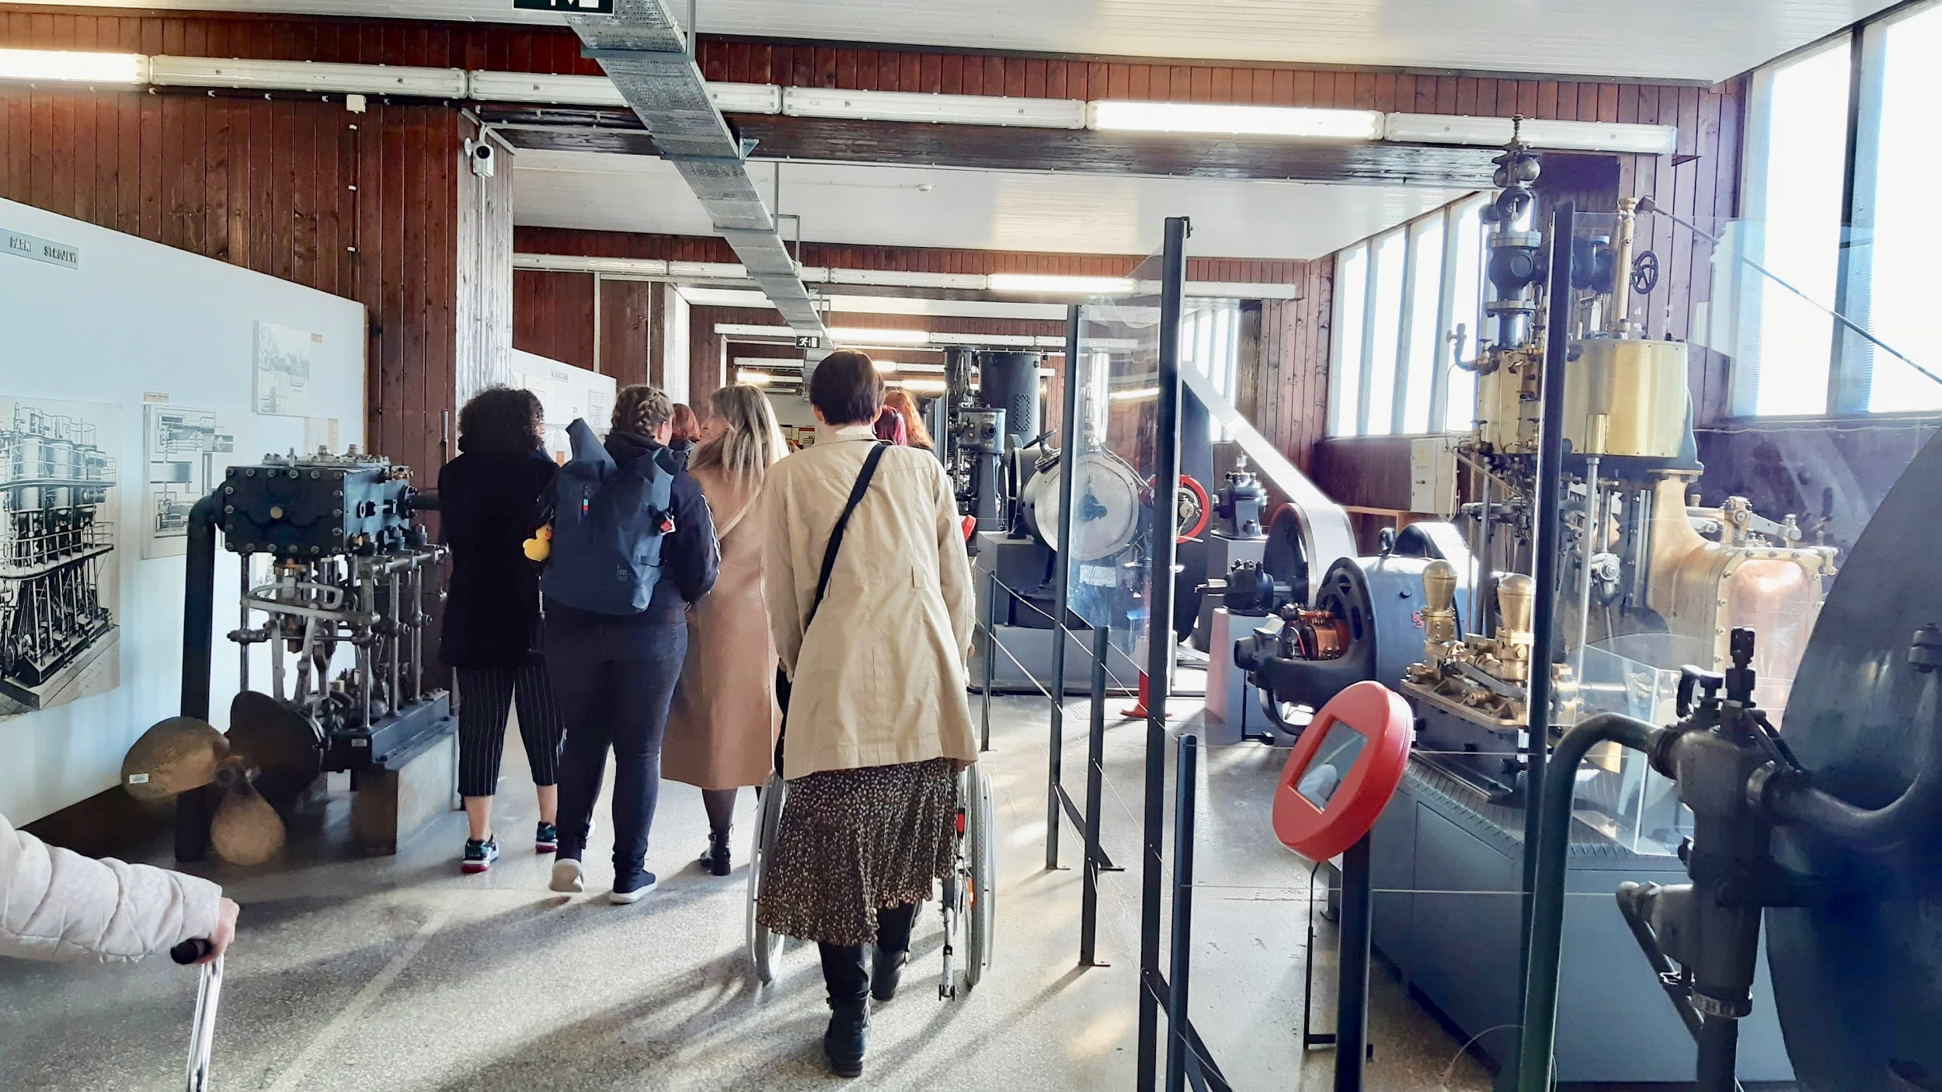
People walking through the aisle of the museum, next to producing energy machines
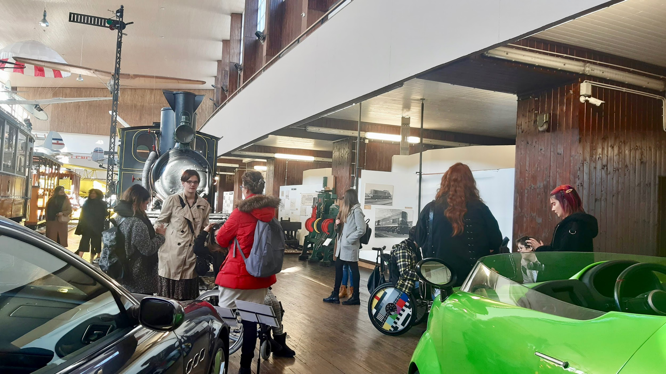
People talking in the Museum, next to a steam locomotive
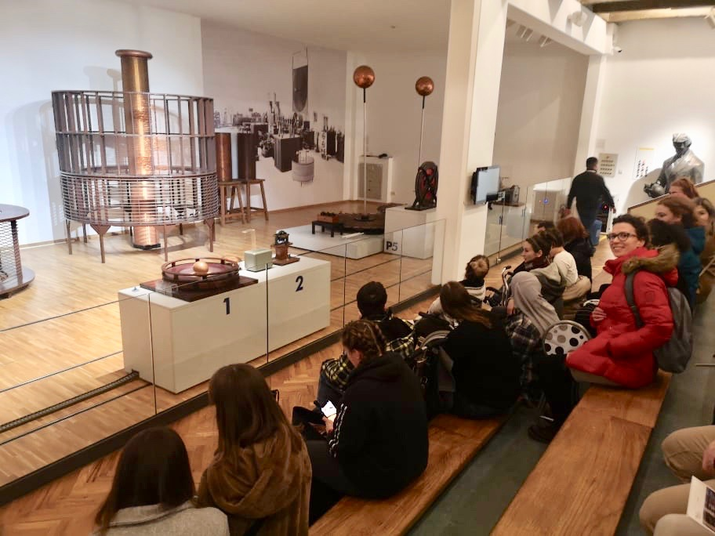
People sitting in front of electric machine made by Nikola Tesla

Photo challenge in the city centre

We went on a city tour organized by Zagreb Youth Centre to better discover Zagreb and learn part of its history. Splitted in 4 groups, we went on a photo challenge of some must-see spots in the city centre. You can find in annexes rules and explanations of the photo challenge.

The purpose of the Zagreb Youth Centre project is to establish and operate the Centre, a venue for a wide range of youth activities and youth lead activities in the local community of the largest Croatian city. The project is being implemented by the ZAMISLI Association with 30 partners, fund by European social fund. All the activities are free of charge and are intended towards young people from 15 to 29. Project coordinators are member of ERYICA https://www.eryica.org/ .

Young people can visit the Youth Info Centre of Zagreb where they can get help in finding all sort of information about education, employment, health, volunteering, culture and the arts, mobility or social policy and law, we are here.

To know more about the Zagreb Youth Centre: https://cmzg.info/

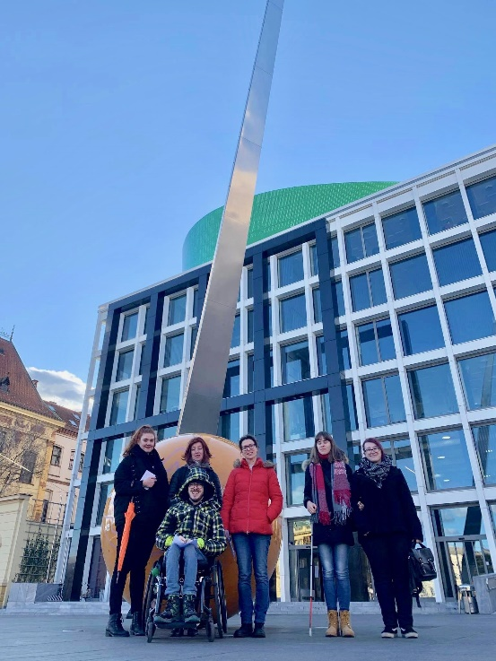
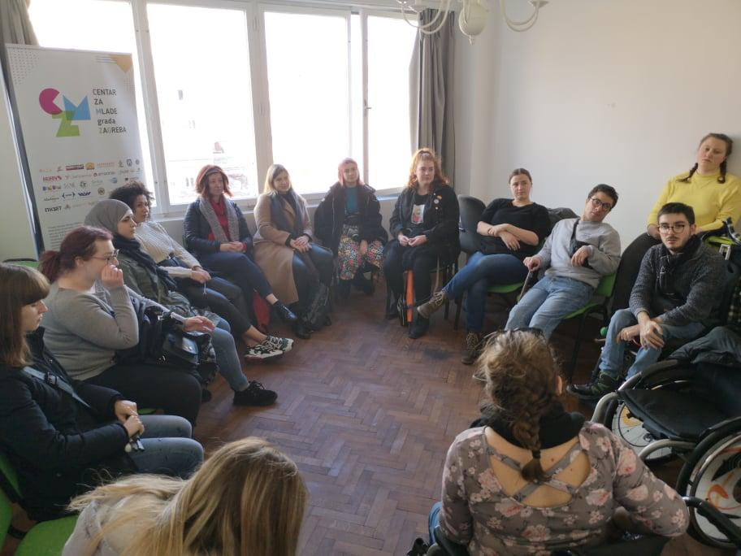
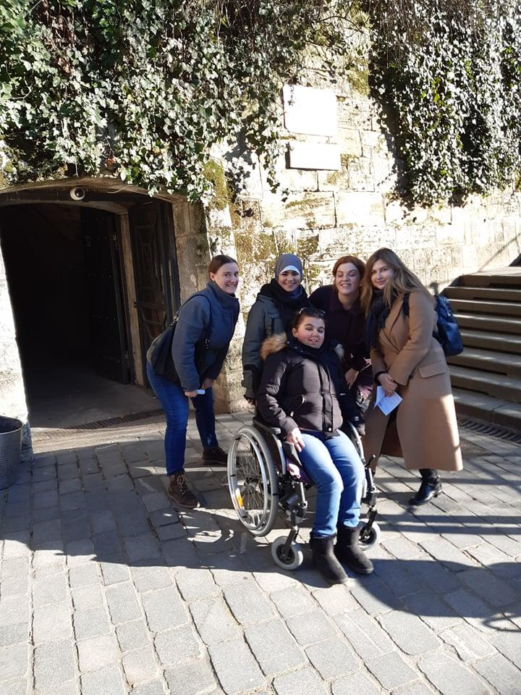
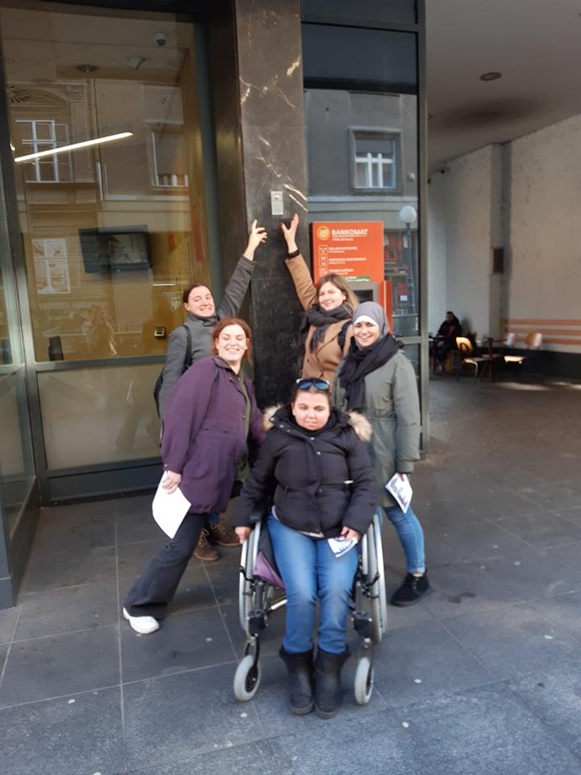
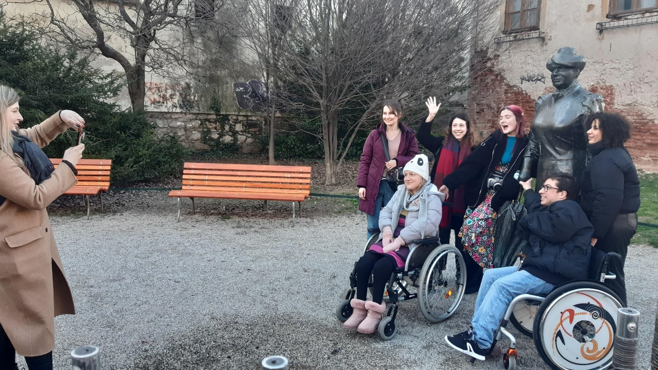

Museum of broken relationships and upper town visit

The Museum of broken relationships is a crowdsourced artistic project celebrating lost, forgotten, heartbroken relationships though objects collected from anonymous people all around the world with stories related to each object.
To know more about the museum and the project : https://brokenships.com/explore

After the museum visit and despite of the icy wind, we sightsaw the upper town of Zagreb and enjoy a nice panoramic view over the lower city.

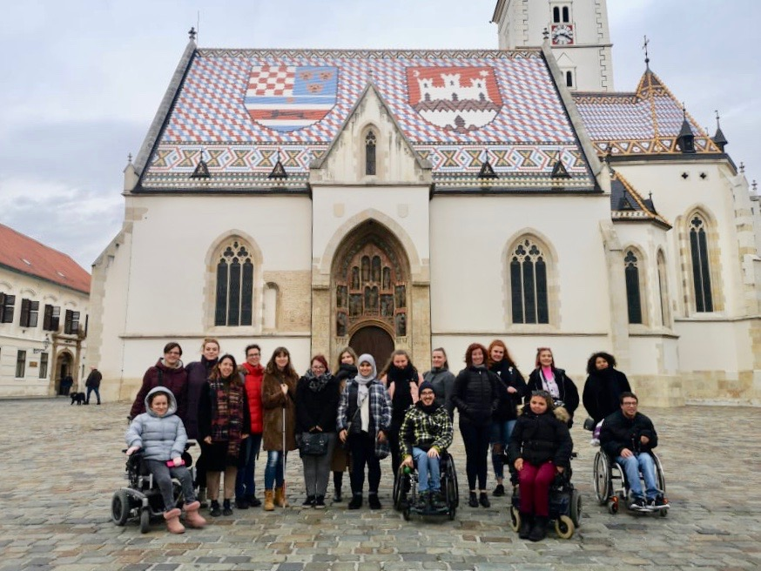

Annexes
Annexes are reduced in this version due to a lot of visual content that cannot be described.

Annex 1: training programme

Zagreb, Laguna Hotel
25th – 29th February 2020

Hour | Activity
Tuesday 25th February
10 :00 | Getting to know each other and definition of objectives
11 :00 | Presentation of training objectives and project
11 :30 | testimonials
12 :00 | Lunch break
14 :00 | International Mobility with Disabilities platform – what information should be provided?
16 :00 | Free afternoon
Wednesday 26th February
10 :00 | Design a toolbox for youth workers
12 :00 | Lunch break
14 :00 | Intercultural games
15 :30 | Free afternoon
Thursday 27th February
10 :00 | Define good criteria for welcoming organizations
12 :00 | Lunch break
14 :00 | Museum (Tehnički muzej)
16 :00 | Free afternoon
Friday 28th February
10 :00 | How to create a community of ambassadors for international mobility with disabilities?
12 : 00 | Lunch break
14 : 00 | Photo challenge in the city centre
17 : 00 | Free evening
Saturday 29th February
10 : 00 | Youthpass workshop
12 : 00 | Lunch break
14 : 00 | Upper city visit + Museum (Muzej prekinutih veza)
17 : 00 | Testimonials collection
19 : 00 | Free evening

Annex 2: International mobility testimonials from Zamisli’s participants

Ivona Separovic presentation and transcript
Is mobility a luxury for people with disabilities?
Hi, everyone, my name is Ivona Šeparović. I am a journalist, and I am 33 years old. Today I'm going to share with you some stories of my challenges with mobility. Firstly, I want you to know that, I actually don't like travelling because of the challenges I will mention today.
When I was a little girl, I travelled with my family a lot, mostly for my treatments and, I must say, I enjoyed it very much. Although travelling always includes lots of challenges and uncertain situations, I felt safe, surrounded with family members. Similar situation was on the excursion at the end of elementary school. My mum was there officially, as one of the teachers, and my sister as my personal assistant. We took a wheelchair and we had no difficulties evading stairs. We had planned everything in detail before the trip and it was fantastic.
At the beginning of high school, I went on a pupils’ exchange trip to Budapest. I wasn’t aware enough of the support I needed, nor confident enough to ask for help. My sister accompanied me as my personal assistant, too. I cannot remember why we hadn’t brought a wheelchair, but it was just one of many problems. Hungarians spoke poor English, and we spoke poor German, so we were communicating in other, most creative ways you could ever imagine.
Although I trusted my high school teachers, there was some misunderstanding in Budapest. My sister and me spent a lot of money on taxis, because we didn’t know the schedule in advance. It seemed to me that stairs were everywhere we went. I was stubborn and I didn’t want to grumble, but I was exhausted of walking and, because of that, avoided sightseeing. Instead, I used all my free time to sleep. I could hardly wait to come home.
Because of this painful experience, I didn’t want to go to high school graduation trip. But my headteacher was determined to find a way for me to enjoy the trip to Spain. We planned every detail in advance and it was one of the best experiences in my life. Nevertheless, general impression was the same as many times before: It was nice, but we walked for ages.
In the year 2009, I travelled to Vilnius (Lithuania) with other Zamisli's volunteers. That‘s when I became aware of all benefits of the airport personal assistance. Open communication in Zamisli's team ensured excellent conditions for my mobility, in spite of many barriers and bad weather conditions.
The following year I went to Namur (Belgium). That trip gave me the opportunity to experience all consequences of inaccessibility. In my sign-up paper I hadn't mentioned that I was a person with disability, so I got a room on the first floor. The hotel only had a delivery elevator. But the inaccessibility adventure had started much earlier, with three train transfers.
The first problem we couldn’t solve showed up in Munich, as I didn't have a Euro key for toilet for persons with disabilities. In fact, every German citizen with disability gets that key by post at their home address. But obviously none had ever thought that some tourist would need it, as well. So, no one at the train station had that key. Yes, this was in Germany!
When we finally got to Namur, the conference which we were attending started with a photo shooting. We had a board on which we were supposed to write what mobility for us is. “Mobility is freedom!”, was the sentence which both the president of Zamisli and I wrote without any consultations. I felt that real freedom only two times during our trip.
1. The first time was also the most memorable to me (in a positive way). It happened in Ghent, when we got on the train to Namur. While entering our train compartment, I met a lady who asked me if I needed any help. I said yes. Although she seemed to have heard me, she didn't move at all. After half a minute of confusion, I asked her if she could help me and she replied: "Could you please, tell me how to do that?" As all of you know, that was the most correct approach possible, but this time it surprised me so much that neither I was ready for it myself.
2. The second surprise was when a waiter at a pizza place in Graz did not want to charge me the coffee I had, because he thought he had humiliated me with the fact that the toilets were upstairs and I needed help to get there. Incredible!
The most interesting fact is that this happened in Graz, the most accessible city I have ever been in. Rooms there were adapted to the smallest detail. For example, they had a shower enclosed by a curtain (without a cabin which is usually hard to close). The rooms were broad, and there were handles inside the shower. The toilet bowls were not raised high, and there were handles on both sides, of course.
In 2012 I graduated from college. Everyone kept asking me: "Where will you go for your graduation journey?". I was thinking a lot about all obstacles I could face, so I decided to do what I really wanted: skip the graduation journey and visit my relatives in Subotica (Serbia) for ten days. I had already known this city well, so my relatives did not suggest any sightseeing, which was a relief. We mostly hung out playing cards and talking a lot.
In 2015 I applied for training "Me too" in Ljubljana (Slovenia), about inclusion of youth with fewer opportunities in social activities. We were discussing accessibility a lot, even before the training started. Organizers provided a wheelchair and a personal assistant for me. I think that openness in communication and planning were the keys to my successful participation. Despite the professionalism and goodwill, we could not avoid all obstacles: I had a shower in my room with a tub that was too high for me and the alternative was a narrow shower cabin that had to be closed during taking shower. Luckily, I had my personal assistant to help me have a shower, but I don’t even want to think what could have happened if I had been there alone.
In April 2019 I visited London. When we arrived at the airport in Venice, the airport assistance was impressive. As soon as we approached one of the staff, he called the person with a special emblem on his suit to help us. He gave us a pager which rang to notify the time I had to be at the Info point. When the assistant approached me, he first asked me who I would like to drive my wheelchair: him, my mum or myself. During security check, you do not go through the detector, but you are examined by a security staff after they ask you whether you allow them to touch you and if you feel any pain in the body. After the security check, you enter an accessible van that takes you directly in front of your plane. The personal assistant and the driver of the van then raise the ramp of the vehicle, which is connected to the door of the airplane. Before getting on the plane, the assistant asks you if you want to walk ten steps leading to the airplane door, or you want to stay in the wheelchair. Only when you sit down in your airplane seat, flight attendants give signal to the airport assistant to leave the plane. After landing, the flight attendant approaches the person with disability, and they wait for another airport assistant together.
What's next? The slopes near zebras are mostly accessible and the road is free of cracks, so there is no fear that the wheelbarrow would fall into a hole. City buses (even double-Deckers) have a special place for a wheelchair and below the handrail there is a bell to let the driver know that you have arrived at the station you need to go out. Getting on and off the bus is no problem, either; if the pavement is not lowered enough and the bus does not have an electric ramp, the driver goes out and lowers the metal ramp. Other passengers patiently wait for their turn to leave the bus, as if they had been warned before to wait for the wheelchair to pass.
Almost every public space in London has a toilet for the disabled, but more accessible than in other countries, as the toilet bowl is lowered and there are handles on each side. Each "normal" toilet in public places is large and wide enough to enter with a wheelchair. Although washbasins in England typically have two taps (separate for hot and cold water), curved washbasins for persons with disabilities have only one, ordinary tap.
Visiting museums and theatres is easy, even if the person in a wheelchair is coming alone. Personal assistance is also provided there, so support staff goes into the elevator with the person with disability.
Staff communicate with the radio, to ensure that no more than three people in wheelchairs are in at the same time, for safety reasons. Of course, before starting the tour or the show, one of the staff always explains to you each next step in advance, asking the same question again and again: "Do you want to walk on that section or you want to stay in the wheelchair?"
It is this "additional" question that completes the story about accessibility and people’s awareness of the problem, which English society, certainly, has. London society (and probably British in general) is aware of the importance of ensuring the conditions for a completely independent life of people with disabilities.
After all these adventures, I have realized that there are, in fact, five keys things for overcoming mobility challenges:
1. Raising awareness of a person with a disability about his or her real needs.
2. Empowering a person with a disability to identify challenges alone and to actively participate in finding a solution needed.
3. Open communication with all participants of mobility trainings.
4. Flexibility in planning activities.
5. Advance planning.
Thank you for your attention!

Nevena Zubcic

Communication kit brainstorming
This section of annexes was meant to regroup diverse idea that people had concerning how to communicate around this project.
Most of them consisted in various print templates with different arrangements and structure.

Zagreb city centre photo challenge
“photo quest” consisting in a tour of zaghreb centre with various places and landmarks”
Quote from the document: Here is a photo challenge that was made part of the training for Erasmus+ project “IMD”. Find every location and take a picture in front of it. Answer the question and learn something new. Let’s start!

Press article

To find the original version of the press article, follow this link https://icm-zg.info/index.php/euro-info-kutak/4038-mobilnost-osoba-s-invaliditetom
ref: Ivona Separovic “Mobilnost osoba s invaliditetom”, 28/02/2020, Informativni centar za mlade zagreb.

English transcript:
to get

End of the document

